a single personal/research statement noting specific areas of research interest

Upload your Personal Statement as “Statement #1” in the “Applicant Statements” section of the online application. Your personal statement should include your top three areas of interest.

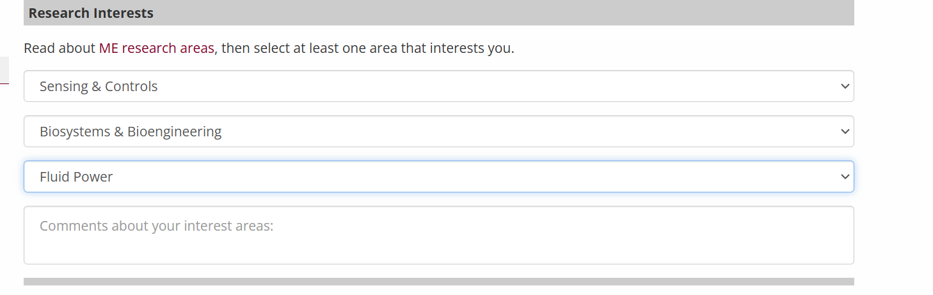

Dear Committee,

I am here to express my research interest in pursuing a PhD degree in Mechanical Engineering. Throughout my studies, I have always been interested in designing new systems to serve a variety of purposes. During my freshman year, I joined a physics club where I learned about machine learning’s application in robotics. One idea that resonated strongly with me was how mathematical algorithms and electronic design could be integrated into an organic system that can make decisions intelligently. This idea propelled me to transfer my major to computer engineering. After switching to the new major, I learned about the development methodology in modern electronic devices and became proficient in C programming skills and FPGA design. I also recognized the necessity to be proficient in predicting my system’s behavior, which inspired me to enroll in high-level physics and statistics courses. In addition, I have been teaching myself mathematic modeling and have completed relevant contests with my friends to prepare myself with a more solid mathematical modeling foundation.  As I wrap up my studies, I want to continue my research in automation and apply the knowledge accumulated from my past experience to my research. Pursuing a PhD in Mechanical Engineering at the University of Minnesota will allow me to further explore my research interest and provide me with new opportunities to contribute to the field.

I started my research on modeling frictional behaviors with mean field theory based on the data collected from cracking materials under high pressure. I analyzed the behavior of the materials using the Complementary Cumulative Distribution Function and explored substantiated parallels in the internal and external friction characteristics of the hydrogel. During this experience, I gained knowledge and experience in conducting research. However, I realized that I preferred research on real devices over theoretical analysis, which was why I switched my major to ECE where I started my second research, which was on Unmanned Aerial Vehicles. I studied, replicated, and tested a virtual platform， “Faster”, which was designed by a team from MIT for automated vehicles to study the behaviors under noises like Gaussian noise and white noise for a flying object. We conducted multiple tests when integrating different types of noise into the environment using the blueprint functionality in Unreal Engine. The test results showed that the algorithm achieved a success rate of approximately 93% in preventing crashes during classic scenarios such as the Hovering noise model and Gaussian noise model. This indicates that the algorithm, originally designed for ground vehicles, is also effective for aerial vehicles. Further optimization of the algorithm and its parameters enabled us to achieve a success rate of nearly 95% in preventing crashes. This is a monumental result for our research as we successfully proved that the new algorithm could be applied to flying devices while achieving solid results. This experience strengthened my ability to use algorithms and math to refine device functionalities.

Even though I was clear at that time that I would like to continue my work on electronic device research, I did not know which area I would like to focus on, until I got a chance to develop a website for AxisMed, a biomedical pre-incubation program at my undergraduate school. At AxisMed, I learned about electronic applications in the biomedical domain, and this experience led to my current study at Boston University. For the first time, I got a chance to design a 3D Hydrophone Scan System from scratch on my own at Dr. Yang’s lab. The system was designed under a very low budget (around thousands of dollars) with an oscilloscope and function generator that are common in most biomedical labs. The system could do μm level scanning through the control of high-accuracy step motors. With special designs that skip the confirmation steps of Arduino and Matlab, we achieved less accurate but faster scanning solutions so that the researchers could obtain a rough idea of the sound field within a short period of time. By adding Wifi modules on Arduino, the system could also support a wireless scan, which is more convenient in the lab environment because of the removal of redundant wires. We also attempted to use the new Arduino R4, which has implanted wifi models, but unfortunately, it is incompatible with Matlab, making it challenging for data visualization and analysis. Still, this experience of designing a system for a practical purpose enhanced my courage to complete a project from scratch and enhance it to perform precise tasks based on the data collected from electronic devices. It also intensifies my interest in the biomedical domain, where the controls require more proficiency and have a larger range of possible applications in math modeling and machine learning, which I have dedicated myself to delving deeper into.

During my study at Boston University, I also gained more in-depth knowledge of power systems and learned that by accepting electronics, many robot designs could be achieved by mechanical design purely like soft robots and fluid power. I would also like to explore more possibilities of involving the above aspects in my future research.

I am eager to continue my academic and professional journey and believe that the University of Minnesota will provide the ideal environment to cultivate my skills. I am excited to contribute my knowledge and passion, and I look forward to the opportunity to grow further.

Sincerely,

Jinzhi Shen